PROJECT REPORT
on
Student Record Management System

Submitted by
AVTAR SINGH
25MCI10325
Avtarsinghraja96@gmail.com
SUBMITTED TO
MS. RUCHIKA DEVI
in partial fulfilment for the award of the degree of

MASTER OF COMPUTER APPLICATIONS ARTIFICIAL INTELLIGENT


Chandigarh University
/ / 2025 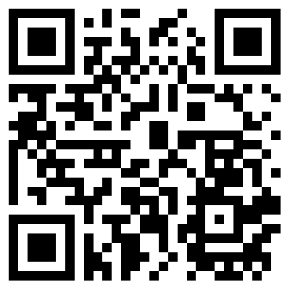

Certificate
This is to certify that avtar singh, a student of Master of Computer Applications (MCA) in Artificial Intelligence, has successfully completed the Minor Project titled “student management” under the esteemed guidance of Ms, Ruchika devi, University Institute of Computing (UIC), Chandigarh University.
This project was undertaken as a part of the academic curriculum and is submitted in partial fulfilment of the requirements for the MCA program. The work presented in this project is a result of independent research, diligent effort, and dedication, demonstrating the student’s ability to apply theoretical knowledge to practical problem-solving.
The project, “Study Room” is a web-based collaborative platform that integrates real-time communication, Pomodoro-based productivity tracking, and resource sharing. It effectively showcases concepts of Advanced Internet Programming, full-stack development, Socket.IObased real-time communication, and database-driven architecture.
I hereby confirm that this project is an original work carried out by the student and has not been submitted elsewhere for the award of any other degree, diploma, or certification.

Ruchika Devi
Assistant Professor
University Institute of Computing
Chandigarh University

Acknowledgement

I would like to express my sincere gratitude to all those who helped and guided me throughout the development of my project “Student Record Management System.”
First and foremost, I am deeply thankful to my project guide/faculty mentor for their valuable guidance, encouragement, and continuous support during the entire process. Their constructive feedback and suggestions were instrumental in improving the quality and functionality of this project.
I also extend my heartfelt thanks to my teachers and department for providing me with the opportunity and resources to work on this project, which has greatly enhanced my practical understanding of Python programming, GUI development, and database management.
Finally, I would like to thank my friends and family for their constant motivation, patience, and encouragement, which inspired me to complete this project successfully.

MCA -ARTIFICIAL INTELLIGENT
Chandigarh University

Contents
Section | Page Number
Abstract | 5
1. Introduction | 6
2. Tools and Technologies Used | 7
3. Implementation Steps | 8
4. Screenshots / Results | 9
5. Conclusion | 10
6. References | 11

Abstract

The Student Record Management System is a desktop-based application built using Python’s Tkinter GUI library and MySQL database connectivity through pymysql. The main goal of this system is to simplify and automate the management of student academic records such as roll number, name, father’s name, subject, and grade. The system provides a user-friendly interface that allows users to add, search, update, delete, and view student records efficiently. Through its tabular data view using Tkinter’s Treeview widget, the application offers an organized and real-time display of data stored in the MySQL database. It also includes input validation, error handling, and success message prompts to improve user experience. This project demonstrates how Python can be used to develop effective database-driven desktop applications that replace manual record-keeping with a faster, accurate, and reliable digital solution.

1. Introduction
Managing student data manually is time-consuming, prone to human errors, and inefficient when dealing with large volumes of records. In most educational institutions, maintaining accurate student information such as roll numbers, subjects, and grades is essential for academic tracking and administrative purposes. The Student Record Management System is developed to address these challenges by providing a simple, secure, and efficient method of storing and handling student information electronically.
This application is built using Python, a high-level programming language known for its simplicity and versatility, combined with the Tkinter library for building an interactive graphical user interface (GUI). The backend database is powered by MySQL, which provides robust and reliable data storage and retrieval capabilities. The connection between the GUI and the database is established using the pymysql module.
The system consists of several key modules:
- Add Student – Allows new student records to be entered and stored in the database.
- Search Student – Enables quick retrieval of student information based on roll number, name, or subject.
- Update Record – Provides the functionality to modify existing student details.
- Delete Record – Removes a student’s data permanently from the database.
- Show All – Displays all stored records in a well-formatted tabular layout.
The interface is designed to be intuitive, with hover effects, color-coded sections, and clearly labeled buttons for ease of navigation. It ensures that both beginners and administrators can operate it without prior technical knowledge. The program also includes input validation and exception handling to ensure that only correct and complete data is stored.
In conclusion, the Student Record Management System effectively demonstrates the integration of GUI programming and database management in Python. It not only reduces paperwork and manual effort but also enhances data accuracy, accessibility, and overall

2. Tools and Technologies Used

The Student Record Management System is developed using a combination of Python, Tkinter, and MySQL, along with supporting libraries and tools. Each component plays a vital role in the functionality and efficiency of the system.

Python:
Python serves as the core programming language for this project due to its simplicity, readability, and powerful libraries. It provides all the essential features required for GUI development, database connectivity, and error handling.

Tkinter (GUI Library):
Tkinter is Python’s built-in library for developing graphical user interfaces. It is used to create the front-end of the application, including buttons, labels, entry boxes, and the main window layout. Tkinter’s ttk.Treeview widget is used to display student records in a structured table format.

MySQL (Database):
MySQL is used as the backend database system to store and manage student data securely. It ensures data integrity, supports fast queries, and handles multiple operations like insertion, searching, updating, and deletion efficiently.

PyMySQL (Connector):
The pymysql library enables communication between the Python application and the MySQL database. It allows the program to execute SQL commands directly from Python, such as inserting, fetching, and updating records.

Tkinter MessageBox & ttk:
These modules enhance user interaction by providing message pop-ups (for success, errors, and alerts) and styled widgets, making the interface more dynamic and user-friendly.

3. Implementation Steps
The development of the Student Record Management System follows a systematic approach, ensuring that each part of the application—from design to execution—works efficiently and reliably. The following steps outline the complete implementation process:
Step 1: Requirement Analysis
The first step involves identifying the system’s objectives, such as storing, updating, deleting, and searching student records efficiently. It also includes deciding the tools and technologies to be used — Python for coding, Tkinter for GUI, and MySQL for database management.
Step 2: Database Design
A database named rec is created in MySQL, containing a table student with fields:
- rollNo (Primary Key)
- name
- fname (Father’s Name)
- sub (Subject)
- grade
This structure ensures proper data storage, indexing, and easy access to student details.
Step 3: GUI Design using Tkinter
The graphical user interface is designed using Tkinter. Frames, labels, buttons, and entry widgets are created to collect user input and display data. A table view (ttk.Treeview) is implemented to show all records in a structured and scrollable format.
Step 4: Database Connectivity
The pymysql library is used to establish a connection between Python and MySQL. The program executes SQL queries to insert, fetch, update, and delete student records directly from the GUI.
Step 5: Function Implementation
Each function in the program performs a specific operation:
- Add Student: Inserts a new record into the database.
- Search Student: Finds and displays a student’s details.
- Update Record: Modifies existing data.
- Delete Record: Removes a record permanently.
- Show All: Displays all student records in the table.
Step 6: Testing and Validation
After coding, the system is tested for various inputs and edge cases to ensure that all features work correctly. Proper validation is added to handle incorrect data and database errors.
Step 7: Final Integration and Execution
All modules are integrated into a single Tkinter window. The final system allows smooth interaction between the user interface and the MySQL database, providing a complete and efficient student management solution.
4. Screenshots/Result

- FIRST PAGE

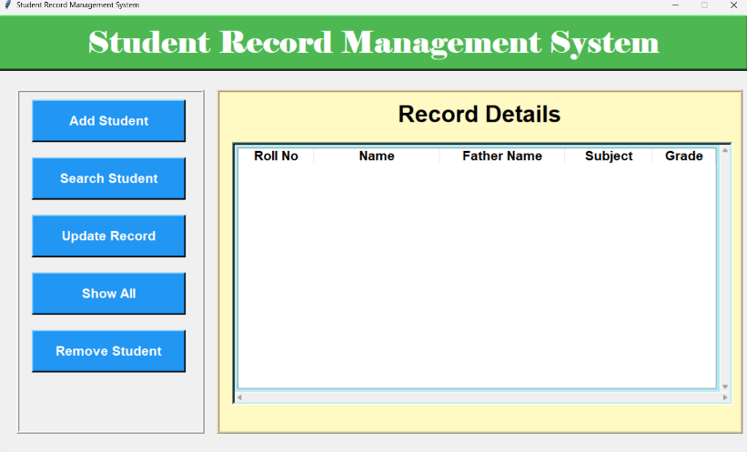

- ADD STUDENT

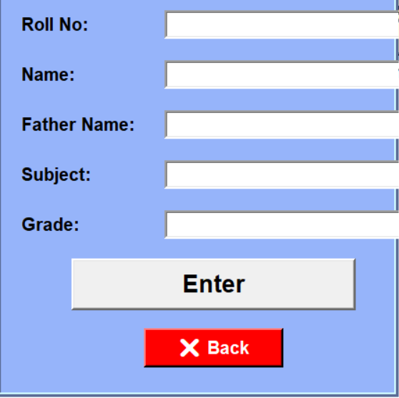

- SEARCH STUDENT

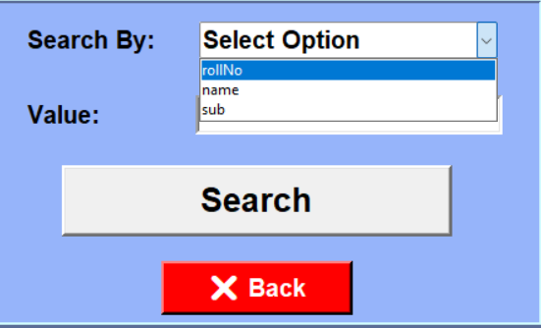

5. Conclusion

The Student Record Management System successfully fulfills its objective of simplifying and automating the management of student data using Python and MySQL. The system provides an easy-to-use graphical interface where users can add, search, update, delete, and display student records efficiently. By integrating Tkinter for GUI and pymysql for database connectivity, the project demonstrates how Python can be used to build practical, database-driven desktop applications.

This application reduces the need for manual record keeping, minimizes human errors, and enhances data accuracy and accessibility. It offers fast retrieval of information, secure storage, and a user-friendly interface suitable for educational institutions. The project also highlights the importance of proper software design, modular programming, and validation in real-world applications.

In conclusion, this system is a reliable, efficient, and scalable solution for managing student records and can be further enhanced with features like login authentication, data export, and report generation to make it even more powerful and professional.

6. References
- React Documentation – https://reactjs.org/docs
- Node.js Documentation – https://nodejs.org/en/docs
- Express.js Guide – https://expressjs.com
- Socket.IO Documentation – https://socket.io/docs
- MySQL Documentation – https://dev.mysql.com/doc
- "Pomodoro Technique," Francesco Cirillo – https://francescocirillo.com/pages/pomodoro-technique
- GITHUB:-https://github.com/AVTARSINGH1234/SQL-PROJECT.git

